[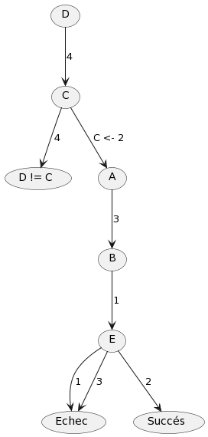](https://www.plantuml.com/plantuml/img/qt3HLD3LjLFGSDPKi58muGBHOBwBWgAj0hgW8uZlh62Zgs341UA01Pr0WiPS81hCTmNn3Rb0D8IVd96QZ4lC624MN9gSV7XbCKZK2000)

| Contrainte propagée à chaque itération | DA | DB | DC | DD | DE | Q  (file d’attente de contraintes) |
| --- | --- | --- | --- | --- | --- | --- |
|  | 234 | 12 | 24 | 4 | 123 | (AC) (AD) (AE) (BC) (BE) (CD) |
| (AC) (AD) | 23 |  |  |  |  | (AE) (BC) (BE) (CD) (AC) (AD) |
| (AE) (BC) (BE) (CD) |  |  | 2 |  |  | (AC) (AD) (BC) (CD) |
| (AC) | 3 |  |  |  |  | (AD) (BC) (CD) (AC) (AE) |
| (AD) (BC) |  | 1 |  |  |  | (CD) (AC) (AE) (BC) (BE) |
| (CD) (AC) (AE) |  |  |  |  | 12 | (BC) (BE) (AE) |
| (BC) (BE) |  |  |  |  | 2 | (AE) (BE) |
| (AE) (BE) | 3 | 1 | 2 | 4 | 2 | Vide |

1.4

| Affections | Da | Db | Dc | Dd | De |  |
| --- | --- | --- | --- | --- | --- | --- |
|  | 234 | 12 | 24 | 4 | 123 |  |
| A <- 2 |  |  | 4 |  | 13 |  |
| B <- 1 |  |  |  |  | 3 |  |
| C <- 4 | 23 |  |  | Vide |  | Échec -> backtrack |
| B <- 2 |  |  |  |  |  |  |
| C <- 4 |  |  |  | Vide |  | Échec -> backtrack |
| A <- 3 |  |  |  |  | 2 |  |
| B <- 1 |  |  |  |  | 2 |  |
| C <- 2 |  | 1 |  |  |  |  |
| D <- 2 |  |  |  |  |  |  |
| E <- 2 | 3 | 1 | 2 | 4 | 5 |  |

## 2 - Modélisation

### Exercice 3

#### Q3.1.

Variables:

* xi = temps de début de tâche ti
* Di = {0, 1, 2, 3, 4, 5, 6, 7}

Contraintes:

t2 et t3 pas en parallèle : x2 ≥ x3 + 3 ou x3 ≥ x2 + 1

⇒ tuples autorisés

(x2, x3) ∈ {(0, 1), (0, 2), (0, 3), (0, 4), (0, 5), (0, 6), (0, 7)

(1, 2), (1, 3), (1, 4), (1, 5), (1, 6), (1, 7)

(2, 3), (2, 4), (2, 5), (2, 6), (2, 7)

(3, 0) (3, 4), (3, 5), (3, 6), (3, 7)

(4, 0), (4, 1) (4, 5), (4, 6), (4, 7)

t3 avant t4 : x4 ≥ x3 + 3

#### Q3.2.

propagation de contraintes:

x4 ≥ x3 + 3 : comme x3 ≥ 0, x4 ≥ 3

⇒ D4 = {3, 4, 5, 6, 7}

comme x4 ≤ 7 ⇒ x3 ≤ 4

D3 = {0, 1, 2, 3, 4}

Aucune propagation.

### Exercice 4

#### Q4.1.

Variable/domaines P : DP = {1, 2, 3}

M : DM = {1,2, 3, 4}, D : DD = {1, 2, 3}

Contraintes:

* P ≠1 ou D ≠ 3
* M ≥ P
* P = 2 et M = 2 ⇒ D = 2
* coutP(P) + coutM(M) + coutD(D) ≤ C